

#### Computer Graphics

#### Name:- Pranjal Tripathi

Sap ID:- 500096030

Roll no. :- R2142210964

Branch:- B.TECH. CSE

Batch:- BAO-1

**Experiment 2**

# **Experiment No.2 : Study of OpenGL window interaction program and Writing First Graphics Program in C**

#include<graphics.h>

#include<conio.h>

main()

{

int gd = DETECT,gm;

initgraph(&gd,&gm,"C:\\tc\\bgi");

setbkcolor(GREEN);

printf("\t\t\t\n\nLINE");

line(50,40,190,40);

printf("\t\t\n\n\nRECTANGLE");

rectangle(125,115,215,165);

printf("\t\t\t\n\n\n\n\n\n\nARC");

arc(120,200,180,0,30);

printf("\t\n\n\n\nCIRCLE");

circle(120,270,30);

getch();

}

**SS of the code :-**

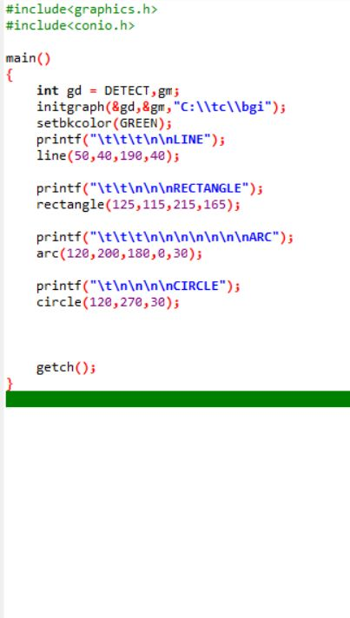

Output :-



**Basic window interaction program**

#include<graphics.h>

#include<conio.h>

int main()

{

int gd = DETECT, gm;

initgraph(&gd, &gm, "C:\\TC\\BGI");

getch();

closegraph();

return 0;

}

**SS of the code :**

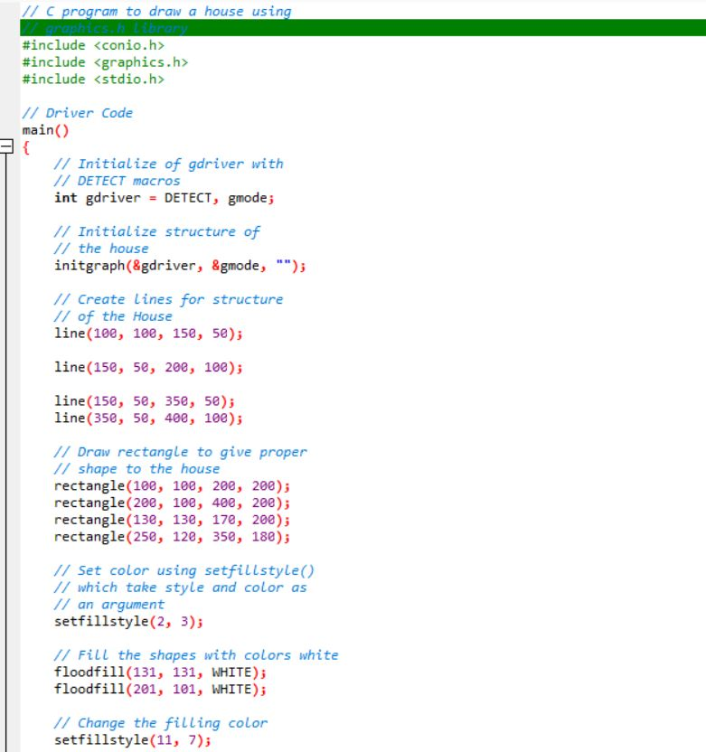

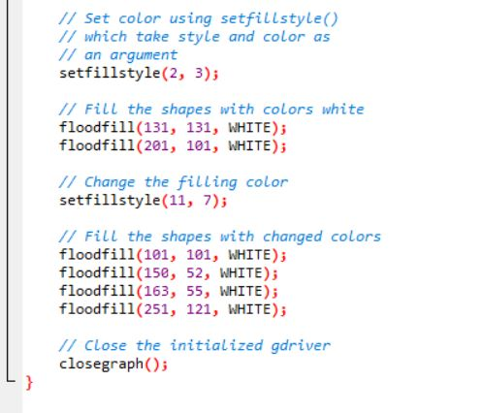

**Output :**

